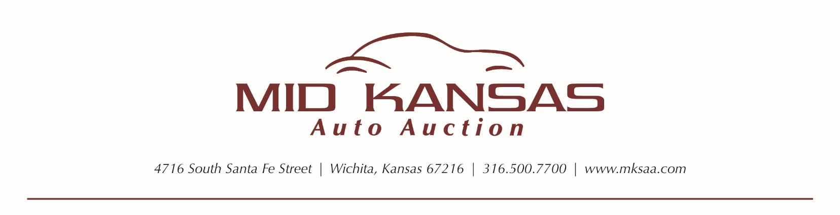

POST SALE INSPECTION OPT-OUT FORM

I request to opt out of automatic post-sale inspections for Online Simulcast/Live Bid purchases. I have read the auction rules understand that in-lane arbitration rules apply, i.e., Ride and Drive guarantee ends at 4 pm CST sale day, and Frame guarantee ends after seven days at close of business, etc. I understand that I am responsible for all transportation expense, including returning the vehicle to the auction, if I wish to arbitrate a vehicle for any issue that would have been discovered through a post-sale inspection.

Signature of this opt-out form confirms my understanding that arbitration of mechanical items of this vehicle are not available under the online 10-day arbitration rules. Individual units may have a PSI purchased by emailing psi@mksaa.com with the VIN, Year, Make, Model and Dealership information by the 4pm sale day cut off.

______________________________
Signature/Date

______________________________
Print Name

______________________________
Company Name

